Week-2:
Connecting computers in LAN, study of basic network commands and n/w configuration commands
Connecting the computers in LAN
Step 1 – Creating a Physical Connection
First you are supposed to do is, connect each end of your LAN cable into both of your computer’s Ethernet Port to connect both computers with each other. If you’re using a modem or router switch then make sure everything is connected properly.

Step 2 LAN Connection Setting
- After connecting two computers.
- Now it’s time to setup an IP address in both computers to make computer to identify the connection.
- You’ll just need to follow the same procedure in both of your computers or maybe laptops.
- Open your Windows Control Panel, or you can search for “Network and Sharing Center” in the Start Menu.
- Select the Network and Sharing Center option.
- From the left sidebar, click on “Change Adapter Settings” option.
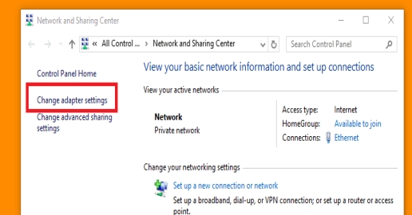
Now, open your “Local Area Connection” or say Ethernet Adaptor’s properties. As shown below.
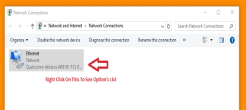
Then select the “Internet Protocol Version 4 (TCP/IPv4)” option and then click on its “Properties” button.
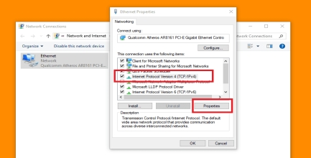

Now when the “Internet Protocol Version 4 (TCP/IPv4) properties” windows get popped up. Enter the IP address manually as shown in the picture given below and click on the “Ok” button after entering it
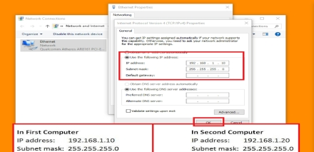

Step 3 – Change Default Sharing Setting:
- After entering the IP Address in both of your computers, now you’ll need to change the sharing setting of your computers to permit access rights for another computer.
- To do that, first, you’ll again have to go back to the Network and Sharing Center settings page of your Windows and then select the “Advanced sharing settings” option to see all your computers network sharing setting.
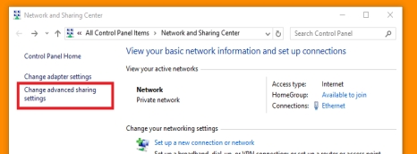
Now, when the sharing setting window gets opened, now you’ll need to change your network setting to those options as shown listed below:
- Turn on network discovery
- Turn on file and printer sharing
- Allow windows to manage home group connection (recommended)
- Turn on sharing so anyone with network access can read and write files in the public folders
- Use 128-bit encryption to help protect files sharing connections (recommended)
- Turn off password protected sharing.
Make these changes in all network profiles;
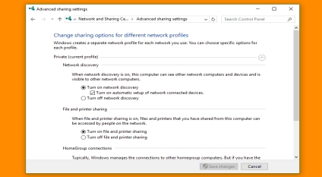
Step 4 – Change Default Workgroup Setting
- By the use of this setting, you can create the same workgroup for both computers to starts sharing.
- Workgroup setting must be same in both your computers but the computer’s name should be different to identify both.
- First, you’ll have to Right click on Computer and then select properties option. (or) press Windows + Pause Break Key on your keyboard to open your system’s properties window.
- After that, click on “Change setting” in workgroup settings category as shown in the picture given below.
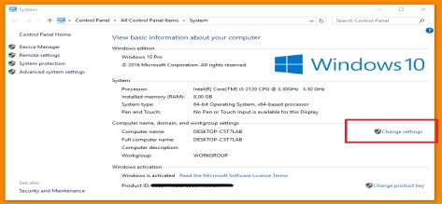

Now in the System properties, you’ll need to click on the change button, and then you will able to see the other options for changing your Computer’s Name. So first, click on the “Change” button then type “WORKGROUP” in the ‘Workgroup:’ options and then click on “ok”. After that, you’ll have to do the same thing again on your different computer which you wanted to connect (or maybe on all computers of your LAN sharing computers).
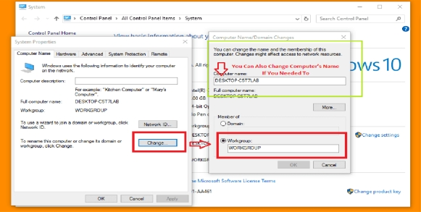
After that click on “Network ID” and do this manual setting as given in the picture given below:
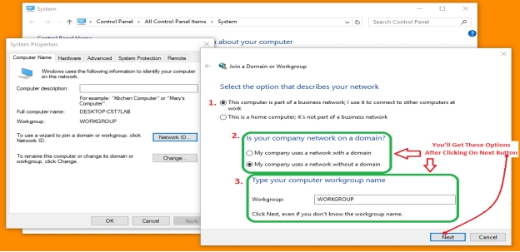
After that click on Finish and restart both of your computers.

Step 5- At Last, Turn on Drive Sharing:
- Now you will able to see your both computer in your windows network place location and to share your drive via network you’ll just need to Turn On the drive sharing by making some changes in that drive’s properties.
- Here’s the list of some steps what you can follow to turn on the drive sharing in your computer or laptop:
1. Right click on your drive and select Properties.
2. Then, select “Sharing”.
3. Then, click on “Advanced Sharing”.
4. Then, tick the “Share this folder”.
5. Then, click on “Permissions”.
6. Then, tick on “Full control”.
7. Then, click on “OK”.
8. At last, click on “OK” again and that’s it.
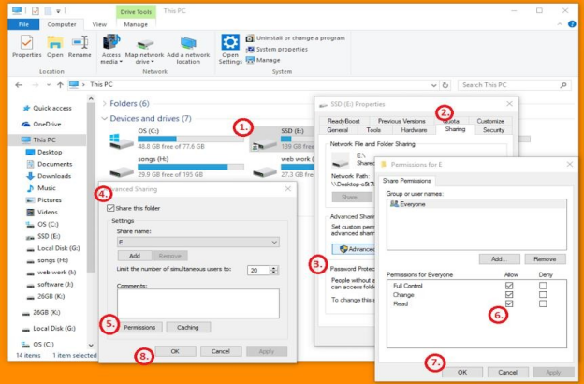

LAN Connection created successfully using Two Computers with a LAN cable.

Study of Basic network commands and network configuration commands
- The Windows operating system provides a tool, i.e., Command Prompt, which allows us to access and configure system settings and data
- Here, we will look into some of the most popular network commands.
- These network commands are helpful when there is a need to configure or troubleshoot the network settings of our system.
1. IPCONFIG 2. NSLOOKUP 3. HOSTNAME 4. PING 5. TRACERT
6. NETSTAT 7. ARP (Address Resolution Protocol) 8. SYSTEMINFO
9. ipconfig /flushdns etc…

C:>ping

- The Ping command is widely used command.
- It allows the user to check the connectivity of our system to another host.
- This command sends four experimental packets to the destination host to check whether it receives them successfully, if so, then, we can communicate with the destination host. But in case the packets have not been received, that means, no communication can be established with the destination host.

C:>ipconfig

The IPCONFIG network command provides a comprehensive view of information regarding the IP address configuration of the device we are currently working on.
Variations of IPConfig command that targets specific system settings or data
→ IPConfig/all - Provides primary output with additional information about network adapters.
→ IPConfig/renew - Used to renew the system’s IP address.
→ IPConfig/release - Removes the system’s current IP address

C:>ipconfig /all

This command displays detailed configuration information about your TCP/IP connection including Router, Gateway, DNS, DHCP, and type of Ethernet adapter in your system.

C:>ipconfig /release

This command allows you to drop the IP lease from the DHCP server.

C:>ipconfig /renew

Using this command will renew all your IP addresses that you are currently (leasing) borrowing from the DHCP server. This command is a quick problem solver if you are having connection issues, but does not work if you have been configured with a static IP address.

C:\>nbtstat –a

This command helps solve problems with NetBIOS name resolution. (Nbt stands for NetBIOS over TCP/IP) Definitions

C:\>arp
The ARP command is used to access the mapping structure of IP addresses to the MAC address. It is short for address resolution protocol; It will show the IP address of your computer along with the IP address and MAC address of your router.
C:\>hostname:

The HOSTNAME command displays the hostname of the system. The hostname command is much easier to use than going into the system settings to search for it

C:\>ipconfig /flushdns:

Flushing the DNS is useful in the removal of bad caches since the flush completely removes all the information stored within the cache.

C:\>nbtstat –a:

This command helps solve problems with NetBIOS name resolution. (Nbt stands for NetBIOS over TCP/IP) Definitions.

C:\netdiag:

Netdiag is a network testing utility that performs a variety of network diagnostic tests, allowing you to pinpoint problems in your network. Netdiag isn’t installed by default, but can be installed from the Windows XP CD after saying no to the install. Navigate to the CD ROM drive letter and open the support\tools folder on the XP CD and click the setup.exe icon in the support\tools folder.

C:\>netstat:

Netstat displays a variety of statistics about computers active TCP/IP connections. This tool is most useful when you’re having trouble with TCP/IP applications such as HTTP, and FTP.

C:\>nslookup:

Using the nslookup command, we can access the information related to our system’s DNS server, i.e., domain name and IP address.

C:\>pathping:

Pathping is unique to Window’s, and is basically a combination of the Ping and Tracert commands. Pathping traces the route to the destination address then launches a 25 second test of each router along the way, gathering statistics on the rate of data loss along each hop.

C:\>route

- The Route command provides the device’s routing tables. To get this result, just type route print.
- A typical computer, with a single network interface, connected to a LAN, with a router is fairly simple and generally doesn’t pose any network problems. But if you’re having trouble accessing other computers on your network, you can use the route command to make sure the entries in the routing table are correct.

C:\>tracert:

- The tracert command displays a list of all the routers that a packet has to go through to get from the computer where tracert is run to any other computer on the internet.
- The TRACERT command is used to trace the route during the transmission of the data packet over to the destination host and also provides us with the “hop” count during transmission.
- Using the number of hops and the hop IP address, we can troubleshoot network issues and identify the point of the problem during the transmission of the data packet.
- Enter in Prompt as below:
C:\> tracert IP-address
OR
C:\> tracert www.destination_host_name.com

